**Magical Piano**

The Player has to play a role of a boy or a girl, who plays piano for people.

To play:

Players have to select their favorite nursery rhyme and play it on the piano. To play the piano, the player has to type the alphabet in the correct order. Few rhymes are correct and to unlock more rhyme player has to complete the given task.

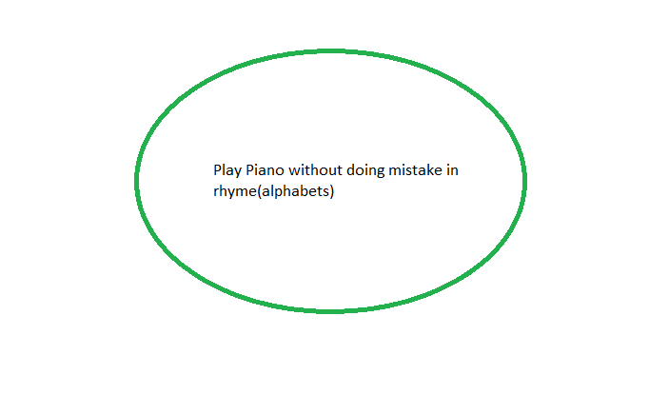

Genre: RPG, Music, Educational game, Text game, Keyboard game.

Secondary objective: Press the right key until the music is over.

First objective: Complete the music with a perfect score.